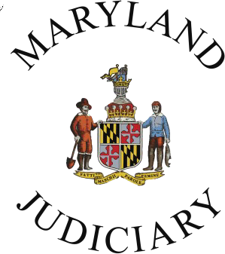
2023 Conflict Resolution Day Bookmark Art Contest Template
Sponsored by the Maryland Judiciary’s Mediation and Conflict Resolution Office (MACRO)
Entries must be postmarked by Thursday, October 19, 2023
Please draw your bookmark entry in the box below. Be sure that your artwork is within the dotted border.
Tips
- For the best results, use bright or dark colors with crayons, markers, pens, or paint.
- If using pencil, please make sure it is dark enough to print.
- If your art includes words, make sure to check your spelling.
- See the reverse side for topic suggestions and other guidelines.

Please print clearly.

Student’s first and last name: Address to return artwork:
____________________________________________ _________________________________________

Age: __________ Grade: __________ _________________________________________

School: ______________________________________ _________________________________________

County: _________________________

Parent, guardian, or teacher’s first and last name: Teacher or parent email address:
___________________________________________ _________________________________________
For notification purposes, if this entry is selected.

2023 Conflict Resolution Day Bookmark Art Contest
Sponsored by the Maryland Judiciary’s
Mediation and Conflict Resolution Office (MACRO)

The 2023 Conflict Resolution Day Bookmark Art Contest is open to all students in Maryland currently in grades K-8. Use the template on the reverse side of this form to create your original artwork. The theme of your submission should focus on peaceful conflict resolution such as listening, respecting differences, talking things out, tolerance, problem-solving together, and peer mediation. Entries can be created with markers, colored pencils, crayons, paint, and pencils, as well as digital art. All entries must be the original work of the student.

By submitting your bookmark entry, you give the Judiciary permission to use your name and grade along with your artwork on display in Judiciary buildings and in any future public awareness materials or media promoting conflict resolution. (Check the box below to decline.) Only one entry per student will be accepted. When printing this template, please use the landscape format.

o Please do not publicly display my artwork in any form.

If you have questions, please email Cheryl Jackson at bookmarkcontest@mdcourts.gov or call 410-260-3540.

Please mail or hand-deliver this entry to:
Maryland Judiciary
Mediation and Conflict Resolution Office (MACRO)
Attn: Cheryl Jackson
187 Harry S. Truman Parkway
Annapolis, MD 21401

Teachers and/or students, please include a return label. More information about the contest is available here.

All entries must be postmarked by Thursday, October 19, 2023.

