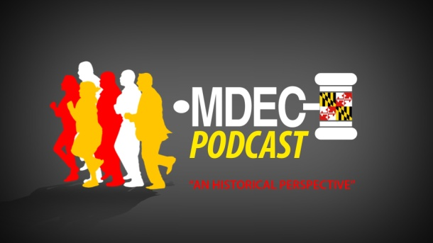
MDEC Podcast Transcript
On Monday April 14, members of the MDEC Advisory Committee met to discuss the project status of the MDEC rollout. The committee, led by Maryland District Court Chief Judge Ben Clyburn and State Court Administrator Pam Harris reviewed key decisions. Also during the meeting, the current timeline for the project was revealed by Joan Nairn, MDEC project manager, and Carla Jones, deputy director of court operations.
Judiciary employees and Maryland attorneys have been hearing about the MDEC project for years. In the following podcast we feature information from the meeting and talk about the real history of the project starting at the beginning in 2009.
How far have we come in the last six years? Let’s begin with a stroll through history…
In 2009, the MDEC Advisory Committee was created. The group decided the project’s scope, vision and implementation strategy. A statewide case management system for all four levels of courts would be implemented with a county by county rollout. A list of features and other needs were compiled and a request for procurement for the software and services was placed. It is worthwhile to note that no other state has ever implemented a rollout in this manner. This meant a much more difficult and complex task, and added many hours of work to the project at all levels.
Also in 2009, the Administrative Office of the Courts began staffing the project. The Court Business Office was created and Joan Nairn was selected as the JIS MDEC Project Manager.
In 2010, the Judiciary hosted a vendor fair and invited court staff to inspect modern case management systems. After a review of some of the most cutting-edge technologies, the Court Business Office selected the project’s functionality requirements. The request for procurement was then issued based on these selected requirements.
A year later, Tyler Technologies was chosen as the vendor for MDEC. The Judiciary’s Project Management Office began intensive planning sessions with Tyler experts to develop an initial implementation of the system. At the same time, focus groups of District Court judges, Circuit Court judges and subject matter experts from several courts began working to provide input on:
- In-chambers workflows.
- In-courtroom case processing, including forms, in-court filings, exhibits and orders.
- Issues and concerns gathered from the courts.
These focus groups were vital for sharing questions and concerns from courts.
The MDEC Executive Steering Committee was also formed to provide a forum for guidance, quick decisions and additional oversight.
In 2012, countless hours of Gap/Fit sessions were held in district and circuit courts. Gap/Fit sessions compare Tyler’s product with the current and future needs of the Judiciary. These sessions included more than 135 court participants who were able to identify 550 “nice to have” items. MDEC planners originally estimated that it would take about 20,000 hours of development to meet court needs, but the actual number climbed to over 35,000 hours to create the new additions to the system. The challenge was to secure a feasible launch date, and that meant trimming the 35,000-plus hours down to something more manageable, both for Tyler Technologies and the Judiciary. So, after many “painful” sessions, it was finally decided that 16,102 hours would be needed to develop everything required for the pilot release.
Also, in 2012, the Steering Committee agreed that multiple vendors would be allowed to come on board to provide e-filing services for court users.
2013 was a year of moving forward and making decisions – including a site visit to New Mexico to see how other courts were integrating new technologies to better serve the public, and the establishment of new rules of procedure under MDEC. One major decision involved electronic payments: How would electronic payments be taken? Should Tyler’s payment portal be used, or should a current payment gateway be used? The decision was made that Tyler’s e-payment portal would be used for e-filing payments entered on the web, as well as over-the-counter payments. It was also decided to continue to use the VitalCheck service for citations.
This brings us to 2014, the year of the MDEC launch. Looking forward this year, we will see further decisions, discussions and planning to launch a successful fall pilot in Anne Arundel County District and Circuit, and Appellate courts.
As we look back, we see that the MDEC initiative has required countless hours of training and preparation, perseverance and commitment. Moving forward requires the same amount of dedication and vision for the future. Every day, individuals across the Judiciary are working to make MDEC a reality.

